Sketch Pad User Guide

The SketchPad is Fairly easy to use, there are 9 buttons on a toolbar which have written a brief summary of what they do.
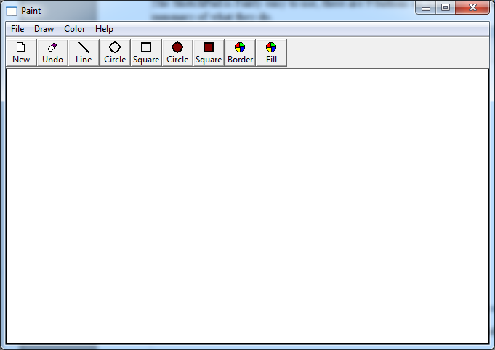
- The First button is a New Page button, this clears the screen of shapes and drawings.

- The Second is an Undo button, the Undo button simply undoes the last shape drawn.

- The Third is a Line Tool, once selected click-hold and drag on the screen the draw lines.

- The Fourth is a Circle Tool for drawing UnFilled circles, again, click-hold and drag the draw a circle from the center outwards.

- The Fifth is a Square Tool, this will draw UnFilled squares, click-hold and drag on the screen to draw.

- The Next two are Filled Circles and Squares, they work in the same way as the UnFilled versions except you can add colour.

- To add Colour you can click on the last two buttons Border and Fill, these will bring up a menu where you can select a color for them

- You an also change the colour of the Lines and Unfilled shapes with the Border Colour Tool, (not the Fill Colour)

Finnaly there are also menu buttons which do exactly what the toolbar buttons do.

